Experiment No.1

Title: Demonstrate the use of Internal, Inline, and External CSS to style a webpage.

Software/Tools Required
- Any text/code editor (e.g., VS Code)
- Web browser (e.g., Chrome, Edge, Firefox) to render and view the HTML page
- Basic knowledge of HTML5 and CSS3

Theory:
HTML (HyperText Markup Language): Defines the core structure and content of web pages using tags (e.g., <h1>, <p>). It relies on CSS for styling and JavaScript for interactivity.
JavaScript: A scripting language used to add interactivity, dynamic behavior, and logic to web pages.
CSS (Cascading Style Sheets): Controls the presentation, formatting, and layout of an HTML document. It can be applied in three ways:
- Inline CSS: Applied directly within an HTML tag using the style attribute. It has the highest priority but is not reusable and is difficult to maintain.
- Internal CSS: Written within a <style> tag in the <head> section of the HTML document. It is useful for styling a single, specific page.
- External CSS: Written in a separate .css file and connected to the HTML document via a <link> tag. This is the most maintainable approach, allowing you to reuse styles across multiple pages.

Output
On opening Exp1.html in a browser, the page displays three sections: Internal CSS, Inline CSS, and External CSS—each showing a heading, a paragraph, and a button styled differently as defined by the respective CSS method. The student's name and PRN are displayed at the top-right corner of the page, as captured in the screenshot below.

Result / Conclusion
The webpage was successfully created and executed, demonstrating Inline, Internal, and External CSS on a single page. The output verifies that all three methods of applying CSS render correctly in the browser, with External CSS providing the most reusable and maintainable approach among the three.
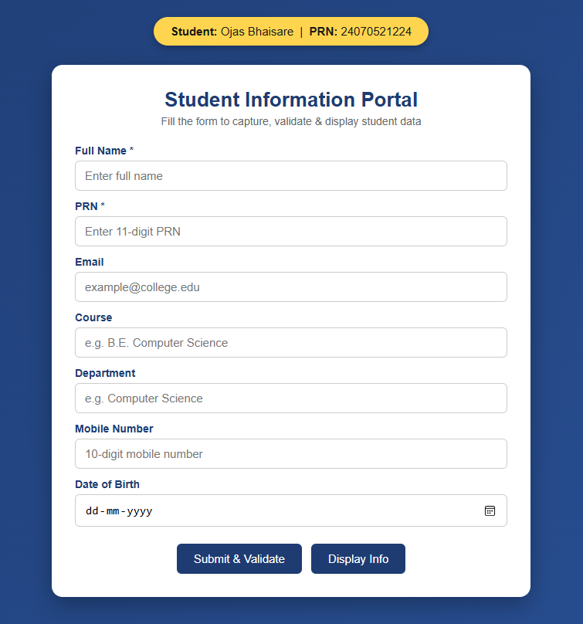

Casestudy – 1

Title: Design a departmental welcome webpage and implement JavaScript DOM manipulation to display student information dynamically.
Software/Tools Required: Visual Studio Code (or any text editor), Web Browser (Google Chrome, Microsoft Edge, Firefox, etc.)
Code:
<!DOCTYPE html>
<html lang="en">
<head>
<meta charset="UTF-8">
<meta name="viewport" content="width=device-width, initial-scale=1.0">
<title>CSE Department - SIT Nagpur</title>
<link rel="stylesheet" href="style.css">
</head>
<body>

<header class="header">
<img src="logo.png.png" alt="SIT Logo" class="college-logo">
<div class="header-text">
<h1>Symbiosis Institute of Technology, Nagpur</h1>
<h2>Department of Computer Science & Engineering</h2>
</div>
</header>

<div class="container">
<div class="card">
<h3>Welcome to CSE Department</h3>
<p>Empowering the 2024-28 batch with modern web development skills and hands-on JavaScript programming.</p>

<button onclick="openStudentPage()" class="btn">View Student Information</button>
</div>
</div>

<script src="script.js"></script>

</body>
</html>

// External JS Program for SIT Nagpur

// 1. Display Alert Box when the page loads
window.onload = function() {
alert("Welcome to SIT Nagpur");

// 2. Using console.log() as per syllabus requirement
console.log("Welcome to Symbiosis Institute of Technology, Nagpur!");
console.log("Department: Computer Science & Engineering");
console.log("Developer: Gunn Fulwani (PRN: 232)");
};

// 3. Function to link and navigate to the Student Information page
function openStudentPage() {
console.log("Navigating to Student Info Page...");
// This JavaScript command changes the page
window.location.href = "student.html";
}

// Function to go back to Department Page
function goBackToDept() {
window.location.href = "department.html";
}

<!DOCTYPE html>
<html lang="en">
<head>
<meta charset="UTF-8">
<meta name="viewport" content="width=device-width, initial-scale=1.0">
<title>Student Profile - SIT Nagpur</title>
<link rel="stylesheet" href="style.css">
</head>
<body>

<header class="header">
<img src="logo.png.png" alt="SIT Logo" class="college-logo">
<div class="header-text">
<h1>Symbiosis Institute of Technology, Nagpur</h1>
<h2>Student Information Portal</h2>
</div>
</header>

<div class="container">
<div class="card student-card">
<h3>Student Profile</h3>
<div class="info-row">
<span class="label">Name:</span>
<span class="value">Gunn Fulwani</span>
</div>
<div class="info-row">
<span class="label">PRN:</span>
<span class="value">232</span>
</div>
<div class="info-row">
<span class="label">Semester:</span>
<span class="value">V</span>
</div>
<div class="info-row">
<span class="label">Course:</span>
<span class="value">Computer Science & Engineering</span>
</div>

<button onclick="goBackToDept()" class="btn btn-secondary" style="margin-top: 20px;">Back to Department</button>
</div>
</div>

<script src="script.js"></script>

</body>
</html>

/* SIT Nagpur Premium Aesthetic Theme */
@import url('https://fonts.googleapis.com/css2?family=Plus+Jakarta+Sans:wght@400;500;700&display=swap');

body {
font-family: 'Plus Jakarta Sans', 'Segoe UI', sans-serif;
margin: 0;
padding: 0;
background-color: #faf9f6; /* Soft aesthetic neutral beige */
color: #2c3e50;
}

/* Glassmorphism Header */
.header {
background: rgba(255, 255, 255, 0.85);
-webkit-backdrop-filter: blur(12px);
backdrop-filter: blur(12px);
padding: 15px 40px;
display: flex;
align-items: center;
border-bottom: 3px solid #b71a22; /* SIT Red */
box-shadow: 0 4px 30px rgba(0,0,0,0.03);
position: sticky;
top: 0;
z-index: 100;
}

.college-logo {
height: 75px;
margin-right: 25px;
transition: transform 0.3s ease;
}

.college-logo:hover {
transform: scale(1.05);
}

.header-text h1 {
margin: 0;
font-size: 1.4em;
color: #b71a22;
letter-spacing: 0.5px;
}

.header-text h2 {
margin: 4px 0 0 0;
font-size: 1.05em;
color: #7f8c8d;
font-weight: 500;
}

/* Main Content Area */
.container {
padding: 60px 20px;
display: flex;
justify-content: center;
animation: fadeIn 0.8s ease-out;
}

/* Premium Card Design with Soft Shadows */
.card {
background-color: #ffffff;
padding: 40px;
border-radius: 16px;
box-shadow: 0 10px 40px rgba(0,0,0,0.06);
max-width: 550px;
width: 100%;
border-top: 5px solid #b71a22;
text-align: center;
transition: transform 0.3s ease, box-shadow 0.3s ease;
}

.card:hover {
transform: translateY(-5px);
box-shadow: 0 15px 50px rgba(0,0,0,0.1);
}

.card h3 {
color: #2c3e50;
margin-top: 0;
font-size: 1.6em;
border-bottom: 2px solid #f4f1ea;
padding-bottom: 15px;
}

.card p {
line-height: 1.8;
color: #555;
margin-bottom: 35px;
font-size: 1.05em;
}

/* Modern Hover Buttons */
.btn {
display: inline-block;
background: linear-gradient(135deg, #b71a22, #8a1319);
color: white;
text-decoration: none;
border: none;
padding: 14px 30px;
border-radius: 30px; /* Pill shape for aesthetic look */
font-size: 1em;
font-weight: 600;
letter-spacing: 0.5px;
cursor: pointer;
box-shadow: 0 4px 15px rgba(183, 26, 34, 0.3);
transition: all 0.3s ease;
}

.btn:hover {
background: linear-gradient(135deg, #a0151c, #6b0f13);
box-shadow: 0 6px 20px rgba(183, 26, 34, 0.4);
transform: translateY(-2px);
}

.btn-secondary {
background: linear-gradient(135deg, #7f8c8d, #636e72);
box-shadow: 0 4px 15px rgba(127, 140, 141, 0.3);
}

.btn-secondary:hover {
background: linear-gradient(135deg, #636e72, #4d5659);
box-shadow: 0 6px 20px rgba(127, 140, 141, 0.4);
}

/* Student Profile Detail Rows */
.student-card {
text-align: left;
}

.info-row {
display: flex;
padding: 15px 10px;
border-bottom: 1px solid #f4f1ea;
transition: background-color 0.2s ease;
border-radius: 8px;
}

.info-row:hover {
background-color: #faf9f6;
}

.info-row .label {
font-weight: 700;
width: 130px;
color: #b71a22;
}

.info-row .value {
color: #34495e;
font-weight: 500;
}

/* Smooth Page Load Animation */
@keyframes fadeIn {
from {
opacity: 0;
transform: translateY(20px);
}
to {
opacity: 1;
transform: translateY(0);
}
}

Output:
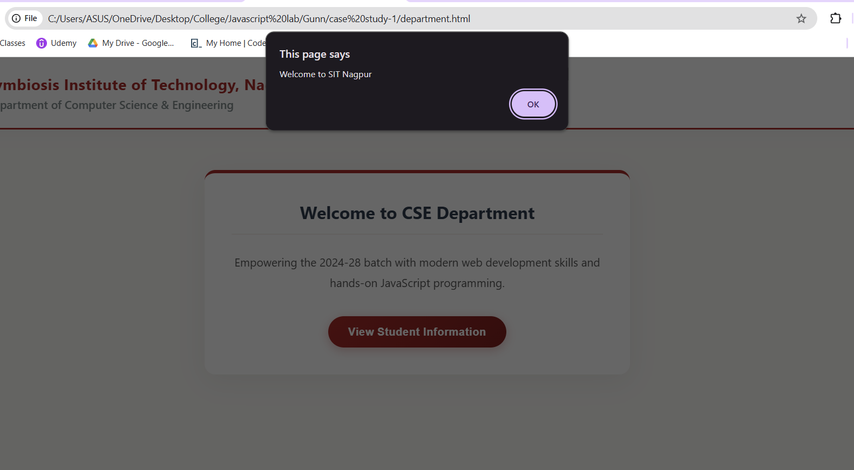
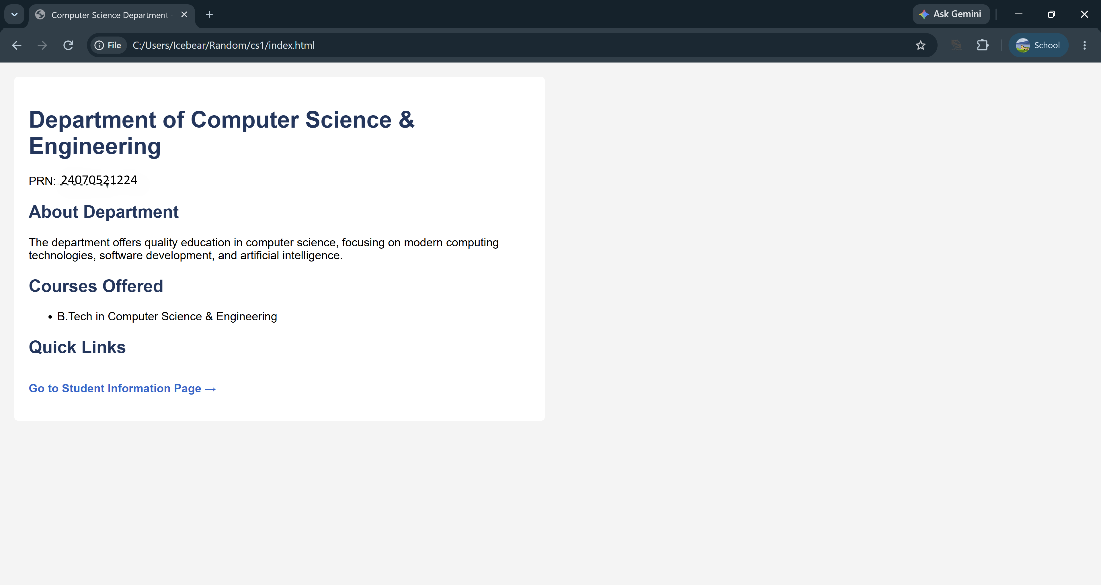

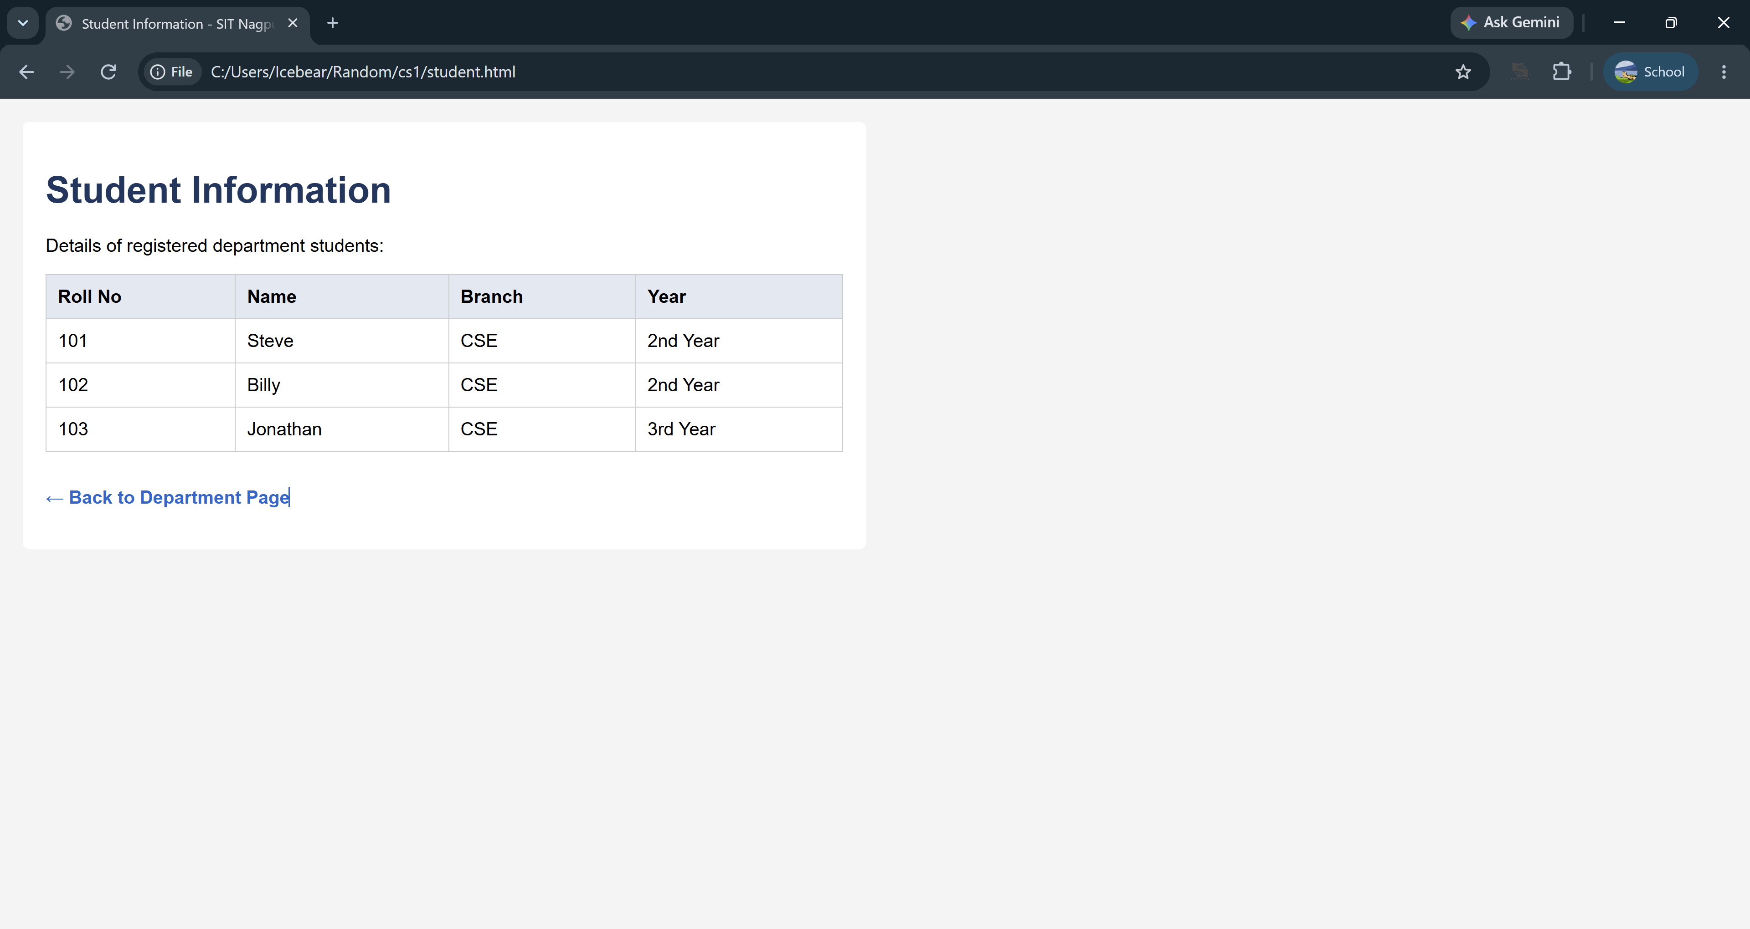
Result/Conclusion: The case study was successfully completed. A professional, responsive departmental welcome page was designed using HTML and CSS, matching the institutional theme. The core functionality of JavaScript DOM manipulation was successfully implemented, allowing the webpage to dynamically render student information upon user interaction via event listeners. This demonstrated a clear separation of concerns between structure (HTML), presentation (CSS), and behavior (JavaScript).

Experiment No.2
Title: Use var, let, const, and demonstrate basic features like template literals and destructuring; build a billing calculator with user input.

Software/Tools Required
- Any text/code editor (e.g., VS Code)
- Web browser (e.g., Chrome, Edge, Firefox) to render and view the HTML page
- Basic knowledge of HTML5 and CSS3

Theory:
JavaScript is a popular scripting language used to create interactive and dynamic web pages. It allows developers to perform calculations, handle user input, and update web content without reloading the page.
In this practical, modern JavaScript features are used to build a simple Billing Calculator that accepts user input and calculates the final bill after applying discount and GST.
The main concepts used are:
- var – Used to declare variables and can be redeclared and updated.
- let – Block-scoped variable that can be updated but not redeclared in the same scope.
- const – Block-scoped variable used for fixed values such as the GST rate.
- Template Literals – Used to display dynamic text by embedding variables using ${}.
- Destructuring – Used to extract values from arrays or objects in a simple and readable way.
The Billing Calculator takes inputs such as product name, quantity, price, discount, and GST. It performs the required calculations and displays the final payable amount in a clear format. This practical helps in understanding modern JavaScript syntax, improves coding efficiency, and demonstrates the real-world use of JavaScript in web development.

Output
On opening the Billing Calculator in a browser, the page displays input fields for the product name, quantity, price, discount, and GST (18%). After the user enters the required details and clicks the Calculate Bill button, the application computes the subtotal, applies the discount, adds the GST amount, and displays the final payable bill. The output is presented in a clear and formatted manner using JavaScript template literals.

Result / Conclusion
The Billing Calculator was successfully developed using modern JavaScript features such as var, let, const, template literals, and destructuring. It correctly accepts user input, calculates the bill by applying discount and 18% GST, and displays the final payable amount. This practical demonstrates the effective use of JavaScript for performing calculations and creating interactive web applications.

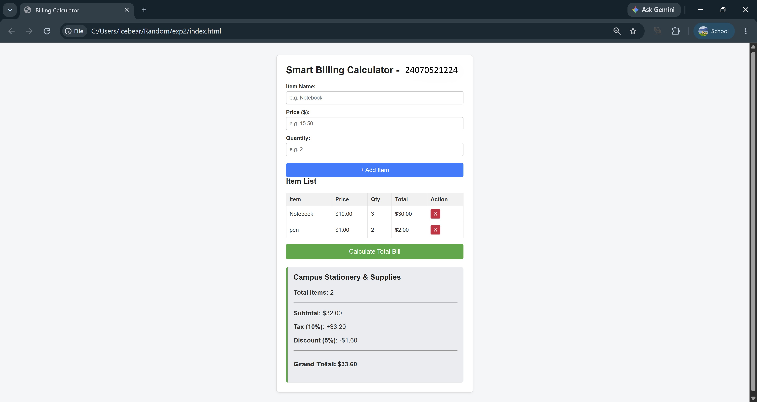

Casestudy – 2
Title: Build a dynamic Retail Billing Calculator using JavaScript DOM manipulation and diverse form controls. Software/Tools Required: Visual Studio Code, Web Browser.
Code :
<!DOCTYPE html>
<html lang="en">
<head>
<meta charset="UTF-8">
<meta name="viewport" content="width=device-width, initial-scale=1.0">
<title>Retail Billing System</title>
<style>
@import url('https://fonts.googleapis.com/css2?family=Plus+Jakarta+Sans:wght@400;500;600;700&display=swap');

/* LILAC DREAM AESTHETIC */
body {
font-family: 'Plus Jakarta Sans', sans-serif;
background-color: #f6f4fa; /* Soft Lavender Background */
color: #322e40;
margin: 0;
padding: 40px 20px;
display: flex;
justify-content: center;
}

.billing-container {
width: 100%;
max-width: 650px;
background: #ffffff;
padding: 35px 40px;
border-radius: 20px;
box-shadow: 0 15px 35px rgba(109, 89, 150, 0.08);
border-top: 6px solid #8b5cf6; /* Vibrant Violet Accent */
}

h2 {
margin: 0 0 15px 0;
font-size: 1.2em;
color: #4c1d95; /* Deep Indigo */
border-bottom: 2px solid #ede9fe;
padding-bottom: 10px;
}

.section-group {
margin-bottom: 30px;
}

.input-row {
display: flex;
gap: 20px;
margin-bottom: 15px;
}

.field {
flex: 1;
}

label {
display: block;
font-size: 0.85em;
font-weight: 600;
color: #5b21b6;
margin-bottom: 8px;
}

input[type="text"], input[type="number"] {
width: 100%;
padding: 12px 14px;
border: 1.5px solid #ddd6fe;
border-radius: 8px;
font-size: 0.95em;
font-family: inherit;
box-sizing: border-box;
outline: none;
transition: all 0.2s;
background: #faf9ff;
}

input[type="text"]:focus, input[type="number"]:focus {
border-color: #8b5cf6;
box-shadow: 0 0 0 3px rgba(139, 92, 246, 0.15);
background: #ffffff;
}

/* Radio & Checkbox Styling */
.radio-group {
display: flex;
gap: 15px;
align-items: center;
font-size: 0.9em;
margin-bottom: 12px;
color: #4c1d95;
font-weight: 500;
}

input[type="radio"], input[type="checkbox"] {
accent-color: #8b5cf6;
transform: scale(1.1);
margin-right: 5px;
cursor: pointer;
}

/* Buttons */
.btn-group {
display: flex;
gap: 15px;
margin-top: 25px;
justify-content: center;
}

button {
padding: 14px 28px;
border: none;
border-radius: 8px;
font-weight: 600;
font-size: 0.95em;
cursor: pointer;
transition: all 0.2s;
}

.btn-primary {
background: #8b5cf6;
color: white;
box-shadow: 0 4px 12px rgba(139, 92, 246, 0.3);
}

.btn-primary:hover {
background: #7c3aed;
transform: translateY(-2px);
}

.btn-secondary {
background: #f1f5f9;
color: #475569;
}

.btn-secondary:hover {
background: #e2e8f0;
}

/* Bill Summary Box */
.summary-box {
background: #faf9ff;
border: 1px solid #ddd6fe;
border-radius: 12px;
padding: 25px;
margin-top: 30px;
display: none;
animation: fadeIn 0.4s ease;
}

@keyframes fadeIn {
from { opacity: 0; transform: translateY(-10px); }
to { opacity: 1; transform: translateY(0); }
}

.summary-box h3 {
margin: 0 0 20px 0;
font-size: 1.4em;
color: #1e1b4b;
}

.summary-row {
display: flex;
justify-content: space-between;
margin-bottom: 12px;
font-size: 0.95em;
color: #4b5563;
}

.summary-divider {
border-top: 1px solid #c4b5fd;
margin: 15px 0;
}

.total-row {
display: flex;
justify-content: space-between;
font-size: 1.15em;
font-weight: 700;
color: #4c1d95;
}
</style>
</head>
<body>

<div class="billing-container">

<!-- SECTION 1: Product Information -->
<div class="section-group">
<h2>Product Information</h2>
<div class="field" style="margin-bottom: 15px;">
<label>Product Name</label>
<input type="text" id="pName" placeholder="e.g., Rice">
</div>
<div class="input-row">
<div class="field">
<label>Quantity (in Kg)</label>
<input type="number" id="qty" placeholder="0" min="0">
</div>
<div class="field">
<label>Rate per Kg (₹)</label>
<input type="number" id="rate" placeholder="0" min="0">
</div>
</div>
</div>

<!-- SECTION 2: Charges & Discounts -->
<div class="section-group">
<h2>Charges & Discounts</h2>
<div class="input-row">
<div class="field">
<label>Discount (%)</label>
<input type="number" id="discount" placeholder="0" min="0">
</div>
<div class="field">
<label>GST (%)</label>
<input type="number" id="gst" placeholder="0" min="0">
</div>
</div>
<div class="field">
<label>Packing Charges (₹)</label>
<input type="number" id="packing" placeholder="0" min="0">
</div>
</div>

<!-- SECTION 3: Payment & Membership -->
<div class="section-group">
<h2>Payment & Membership</h2>
<label style="margin-bottom: 10px;">Payment Mode</label>
<div class="radio-group">
<label><input type="radio" name="payMode" value="Cash"> Cash</label>
<label><input type="radio" name="payMode" value="Card"> Card</label>
<label><input type="radio" name="payMode" value="UPI" checked> UPI</label>
</div>

<div class="radio-group" style="margin-top: 15px;">
<label><input type="checkbox" id="membership" checked> Membership (Yes/No)</label>
</div>
</div>

<!-- Bill Summary Output -->
<div id="summaryBox" class="summary-box">
<h3>Bill Summary</h3>
<div class="summary-row">
<span>Product Cost (Qty × Rate):</span>
<span id="outCost">₹ 0.00</span>
</div>
<div class="summary-row">
<span id="outDiscountLabel">Discount (0.00%):</span>
<span id="outDiscountAmt">- ₹ 0.00</span>
</div>
<div class="summary-row" style="font-weight: 600; color: #322e40;">
<span>Subtotal:</span>
<span id="outSubtotal">₹ 0.00</span>
</div>
<div class="summary-row">
<span id="outGstLabel">GST (0.00%):</span>
<span id="outGstAmt">+ ₹ 0.00</span>
</div>
<div class="summary-row">
<span>Packing Charges:</span>
<span id="outPacking">+ ₹ 0.00</span>
</div>

<div class="summary-divider"></div>

<div class="total-row">
<span>Total Bill Amount:</span>
<span id="outTotal">₹ 0.00</span>
</div>
</div>

<!-- Action Buttons -->
<div class="btn-group">
<button class="btn-primary" onclick="calculateBill()">Calculate Bill</button>
<button class="btn-secondary" onclick="clearForm()">Clear Form</button>
</div>

</div>

<script>
function calculateBill() {
// 1. Fetch Values
const qty = Number(document.getElementById('qty').value) || 0;
const rate = Number(document.getElementById('rate').value) || 0;
const discPerc = Number(document.getElementById('discount').value) || 0;
const gstPerc = Number(document.getElementById('gst').value) || 0;
const packing = Number(document.getElementById('packing').value) || 0;

// 2. Mathematical Calculations (Exactly matching screenshot logic)
const productCost = qty * rate;
const discountAmt = productCost * (discPerc / 100);
const subtotal = productCost - discountAmt;
const gstAmt = subtotal * (gstPerc / 100);
const totalBill = subtotal + gstAmt + packing;

// 3. Update DOM Output
document.getElementById('outCost').innerText = `₹ ${productCost.toFixed(2)}`;

document.getElementById('outDiscountLabel').innerText = `Discount (${discPerc.toFixed(2)}%):`;
document.getElementById('outDiscountAmt').innerText = `- ₹ ${discountAmt.toFixed(2)}`;

document.getElementById('outSubtotal').innerText = `₹ ${subtotal.toFixed(2)}`;

document.getElementById('outGstLabel').innerText = `GST (${gstPerc.toFixed(2)}%):`;
document.getElementById('outGstAmt').innerText = `+ ₹ ${gstAmt.toFixed(2)}`;

document.getElementById('outPacking').innerText = `+ ₹ ${packing.toFixed(2)}`;

document.getElementById('outTotal').innerText = `₹ ${totalBill.toFixed(2)}`;

// Make the summary box visible
document.getElementById('summaryBox').style.display = 'block';
}

function clearForm() {
// Clear all text and number inputs
document.getElementById('pName').value = '';
document.getElementById('qty').value = '';
document.getElementById('rate').value = '';
document.getElementById('discount').value = '';
document.getElementById('gst').value = '';
document.getElementById('packing').value = '';

// Reset radios and checkboxes to default state
document.querySelector('input[name="payMode"][value="UPI"]').checked = true;
document.getElementById('membership').checked = true;

// Hide summary box
document.getElementById('summaryBox').style.display = 'none';
}
</script>
</body>
</html>

Output:
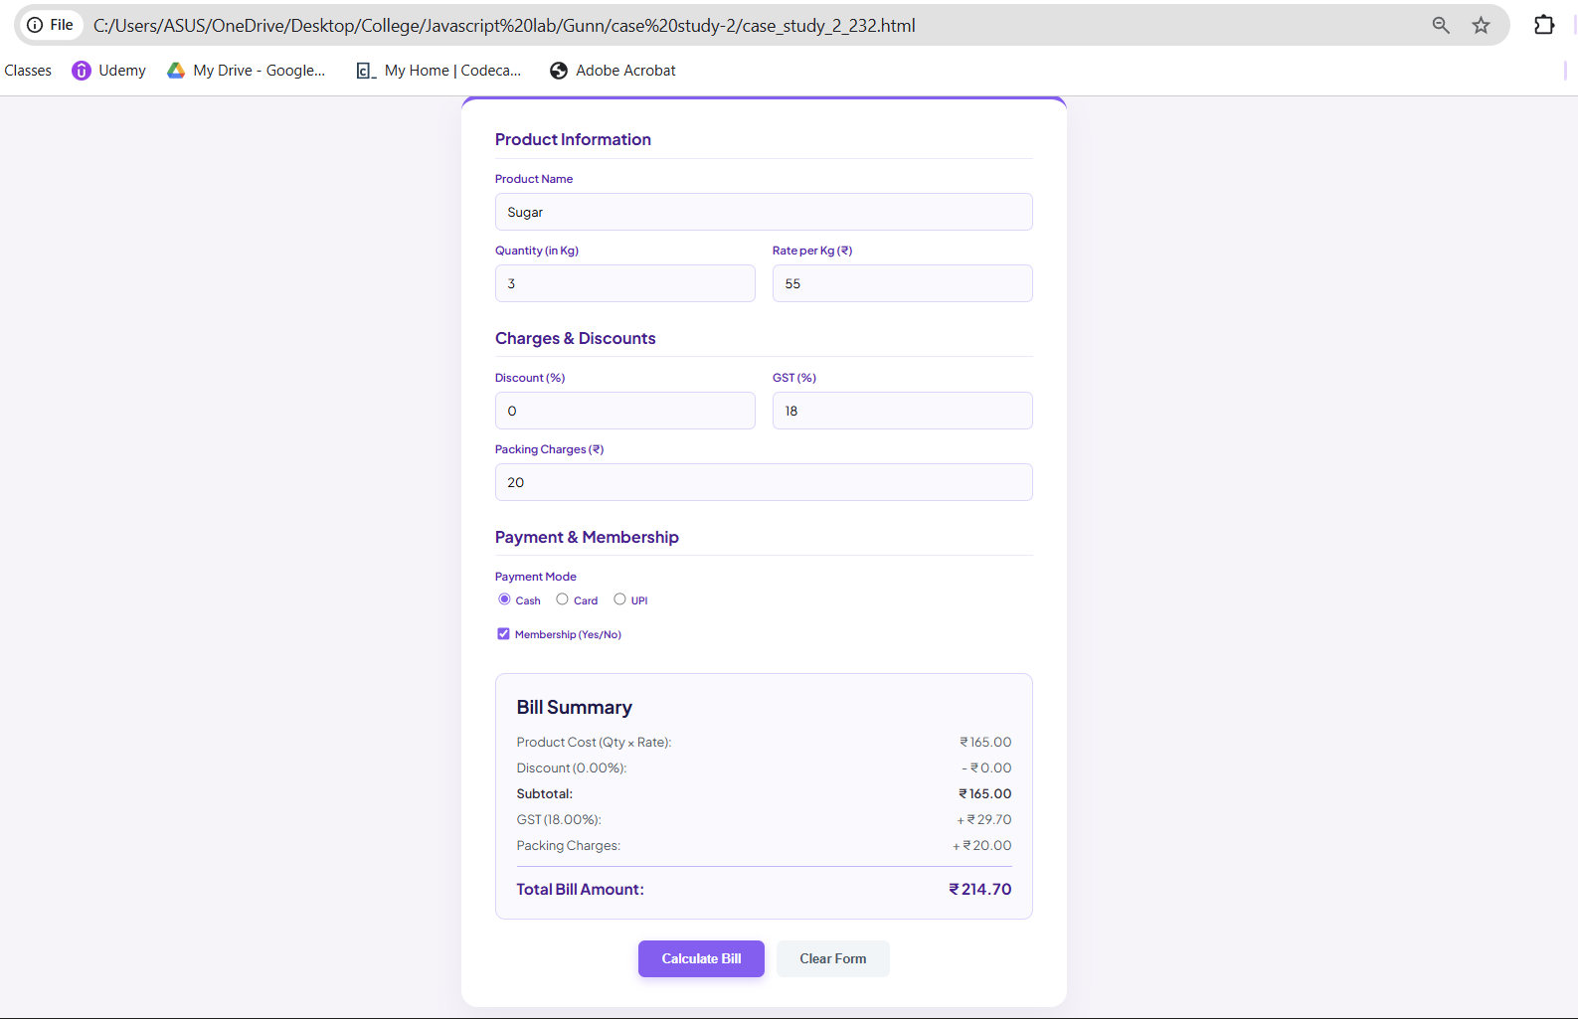
Result/Conclusion: The case study was successfully completed. A comprehensive retail billing calculator was developed using HTML, CSS, and JavaScript. The program successfully retrieved data from various input types (text, number, radio, checkbox), executed sequential financial arithmetic (including discount and GST percentages), and dynamically injected the formatted itemized bill into the webpage's DOM.

Experiment No.3
Title: Implement control structures and form validation; create a grading system based on user-entered marks.

Software/Tools Required
- Any text/code editor (e.g., VS Code)
- Web browser (e.g., Chrome, Edge, Firefox) to render and view the HTML page
- Basic knowledge of HTML5 and CSS3

Theory:
JavaScript is a client-side scripting language used to create dynamic and interactive web pages. It provides control structures such as if, if-else, else-if, switch, and loops to control the flow of a program based on conditions. Form validation ensures that the user enters valid data before processing it, reducing errors and improving reliability. In this practical, the user enters marks between 0 and 100, and the program first validates the input. If the entered marks are valid, the program uses if-else statements to assign grades according to the following criteria: 90–100 = A+, 80–89 = A, 70–79 = B, 60–69 = C, 50–59 = D, and below 50 = Fail.

Output:
- Input: Marks = 95 → Output: Grade: A+
- Input: Marks = 76 → Output: Grade: B
- Input: Marks = 48 → Output: Grade: Fail
- Input: Marks = 120 → Output: Marks should be between 0 and 100.
- Input: Empty field → Output: Please enter marks.

Result/Conclusion:
The grading system was successfully implemented using JavaScript control structures and form validation. The program accurately validates the user-entered marks, prevents invalid inputs, and assigns the correct grade based on predefined conditions. This practical demonstrates the effective use of conditional statements and input validation to create a simple, reliable, and user-friendly web application.

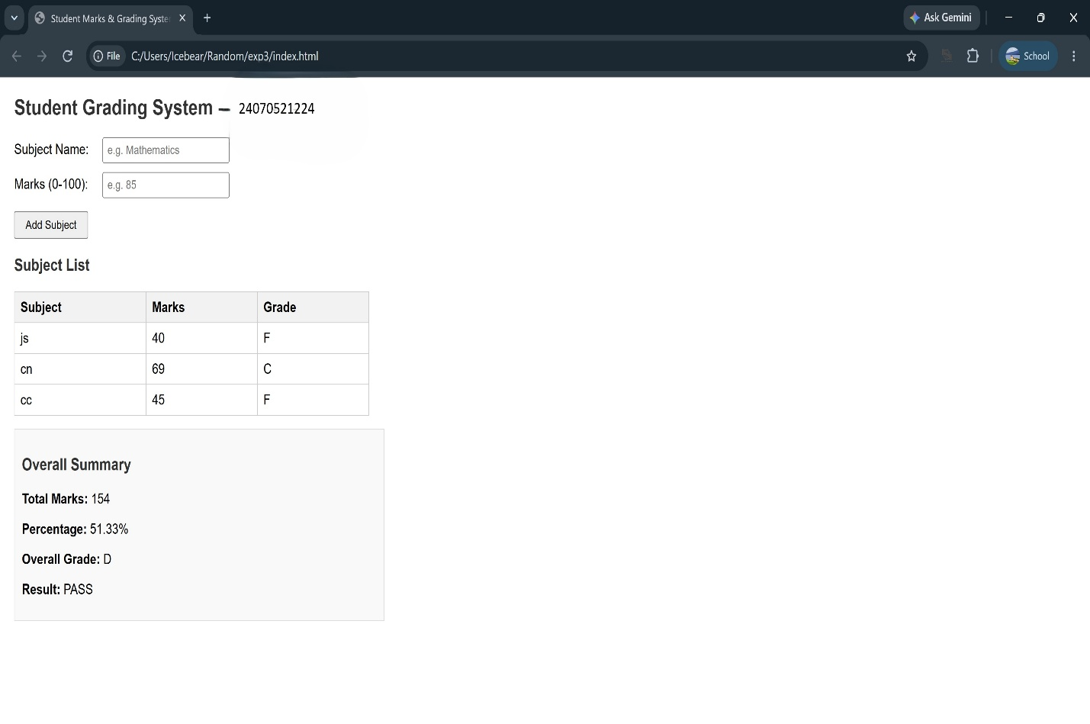
Casestudy – 3
Title: Write a JavaScript program that accepts student marks and displays the scholarship category using conditional control structures.
Software/Tools Required: Visual Studio Code (or any text editor), Web Browser (Google Chrome, Microsoft Edge, Firefox, etc.)
Code:
<!DOCTYPE html>
<html lang="en">
<head>
<meta charset="UTF-8">
<meta name="viewport" content="width=device-width, initial-scale=1.0">
<title>Scholarship Eligibility Checker</title>
<style>
@import url('https://fonts.googleapis.com/css2?family=Inter:wght@400;500;600;700&display=swap');

/* NORDIC ICE & SAGE GREEN AESTHETIC */
body {
font-family: 'Inter', sans-serif;
background-color: #f4f7f6; /* Soft Ice/Grey-Green Background */
display: flex;
justify-content: center;
align-items: center;
height: 100vh;
margin: 0;
color: #2c3e50;
}

.card {
background-color: #ffffff;
width: 100%;
max-width: 420px;
padding: 40px;
border-radius: 16px;
box-shadow: 0 10px 30px rgba(0, 0, 0, 0.04), 0 1px 3px rgba(0,0,0,0.02);
text-align: center;
border-top: 5px solid #789c78; /* Sage Green Accent */
}

h2 {
margin-top: 0;
margin-bottom: 25px;
font-size: 1.6em;
color: #333;
font-weight: 700;
line-height: 1.3;
}

.input-group {
text-align: left;
margin-bottom: 20px;
}

label {
display: block;
font-size: 0.9em;
font-weight: 600;
color: #555;
margin-bottom: 8px;
}

input[type="number"] {
width: 100%;
padding: 12px 15px;
font-size: 1em;
font-family: inherit;
border: 1.5px solid #d1d9d4;
border-radius: 8px;
box-sizing: border-box;
outline: none;
transition: all 0.2s ease;
background-color: #fcfdfc;
}

input[type="number"]:focus {
border-color: #789c78;
box-shadow: 0 0 0 3px rgba(120, 156, 120, 0.15);
}

.btn-check {
width: 100%;
padding: 14px;
background-color: #789c78; /* Classy Sage Green */
color: #ffffff;
border: none;
border-radius: 8px;
font-size: 1em;
font-weight: 600;
cursor: pointer;
transition: background-color 0.2s ease, transform 0.1s ease;
}

.btn-check:hover {
background-color: #648564;
transform: translateY(-1px);
}

.result-box {
margin-top: 20px;
padding: 15px;
background-color: #eef2ef; /* Soft grey matching screenshot */
border: 1px solid #dcdcdc;
border-radius: 8px;
font-size: 0.95em;
font-weight: 500;
color: #333;
display: none; /* Hidden by default */
animation: fadeIn 0.3s ease-in-out;
}

@keyframes fadeIn {
from { opacity: 0; transform: translateY(-5px); }
to { opacity: 1; transform: translateY(0); }
}
</style>
</head>
<body>

<div class="card">
<h2>Scholarship Eligibility<br>Checker</h2>

<div class="input-group">
<label for="marks">Enter Student Marks (0-100):</label>
<input type="number" id="marks" min="0" max="100" placeholder="e.g. 95">
</div>

<button class="btn-check" onclick="checkEligibility()">Check Eligibility</button>

<div id="output" class="result-box"></div>
</div>

<script>
function checkEligibility() {
const marksInput = document.getElementById('marks').value;
const outputBox = document.getElementById('output');

// Validation: Check if input is empty or out of range
if (marksInput === '' || marksInput < 0 || marksInput > 100) {
outputBox.innerHTML = "<span style='color: #c0392b;'>⚠️ Please enter valid marks between 0 and 100.</span>";
outputBox.style.display = "block";
outputBox.style.backgroundColor = "#fdf0f0";
return;
}

const marks = Number(marksInput);
let scholarship = "";

// If-Else Ladder for Scholarship Categories
if (marks >= 90) {
scholarship = "Platinum Scholarship";
} else if (marks >= 75) {
scholarship = "Gold Scholarship";
} else if (marks >= 60) {
scholarship = "Silver Scholarship";
} else if (marks >= 40) {
scholarship = "Bronze Scholarship";
} else {
scholarship = "No Scholarship";
}

// Displaying exact format requested in screenshot
outputBox.innerHTML = `<strong>Marks:</strong> ${marks} &nbsp; <strong>Scholarship:</strong> ${scholarship}`;

// Resetting background color in case of previous error
outputBox.style.backgroundColor = "#eef2ef";
outputBox.style.display = "block";
}
</script>
</body>
</html>

Output:
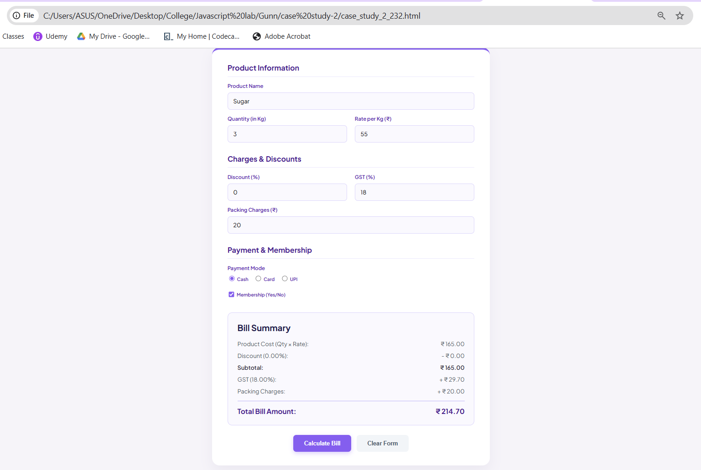
Result/Conclusion: The case study was successfully completed. A dynamic JavaScript program was developed to accept numerical marks, validate the input range, and apply a sequential if-else logic ladder to determine the correct scholarship tier (e.g., Platinum, Gold, Silver, Bronze). The core logic was successfully integrated with the front-end, allowing the result to be dynamically displayed on the web interface using DOM manipulation techniques without requiring a page reload.

Experiment No.4
Title: Use function types, scope, and closures; apply try-catch; build a palindrome checker.

Software/Tools Required
- Any text/code editor (e.g., VS Code)
- Web browser (e.g., Chrome, Edge, Firefox) to render and view the HTML page
- Basic knowledge of HTML5 and CSS3

Theory:
JavaScript functions are used to perform specific tasks in a program. Functions can be of different types such as named functions, anonymous functions, and arrow functions. Scope defines where a variable can be accessed in a program, while a closure allows a function to remember variables from its outer function even after it has finished executing. The try-catch statement is used to handle errors and prevent the program from crashing. In this practical, the user enters a word or sentence, and the program checks whether it is a palindrome by comparing the original text with its reverse. If the input is invalid or empty, an appropriate error message is displayed.

Output:
- Input: madam → Output: Palindrome
- Input: racecar → Output: Palindrome
- Input: hello → Output: Not a Palindrome
- Input: A man a plan a canal Panama → Output: Palindrome
- Input: Empty Field → Output: Please enter valid text.

Result/Conclusion:
The palindrome checker was successfully implemented using JavaScript functions, scope, closures, and try-catch. The program correctly checks whether the entered text is a palindrome and handles invalid input without stopping the execution, making it simple, reliable, and user-friendly.
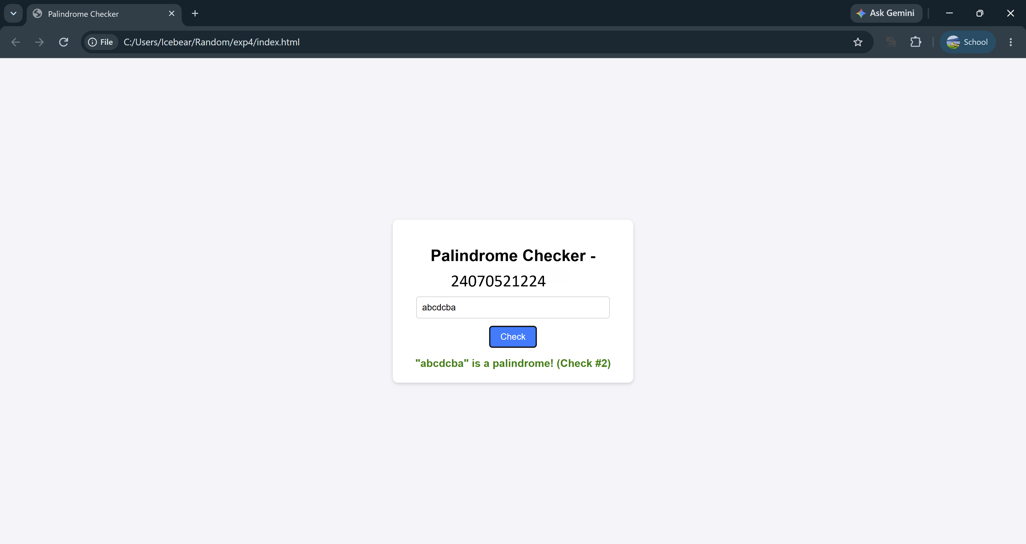

Casestudy – 4
Yeh raha tera Case Study 4 (ATM Card PIN Verification) ka detailed lab manual write-up. Ise tu seedha apne document mein paste kar sakti hai:
Case Study 4
Title: Real-Time Case Study: ATM Card PIN Verification Using JavaScript Functions (Palindrome Checker).
Software/Tools Required: Visual Studio Code (or any text editor), Web Browser (Google Chrome, Microsoft Edge, Firefox, etc.)
Code:
<!DOCTYPE html>
<html lang="en">
<head>
<meta charset="UTF-8">
<meta name="viewport" content="width=device-width, initial-scale=1.0">
<title>Secure Banking | PIN Verification</title>
<style>
@import url('https://fonts.googleapis.com/css2?family=Roboto:wght@400;500;700&family=Courier+Prime:wght@700&display=swap');

/* CORPORATE BANKING THEME */
body {
font-family: 'Roboto', sans-serif;
background-color: #f0f2f5; /* Standard corporate light grey */
color: #333333;
margin: 0;
display: flex;
flex-direction: column;
align-items: center;
min-height: 100vh;
}

/* Fake Bank Header */
.bank-navbar {
width: 100%;
background-color: #003366; /* Deep Navy Blue */
color: white;
padding: 15px 20px;
box-shadow: 0 2px 4px rgba(0,0,0,0.1);
display: flex;
justify-content: space-between;
align-items: center;
box-sizing: border-box;
}

.bank-navbar h2 {
margin: 0;
font-size: 1.4em;
letter-spacing: 1px;
display: flex;
align-items: center;
gap: 10px;
}

.container {
width: 100%;
max-width: 450px;
background: #ffffff;
margin-top: 50px;
border: 1px solid #d1d5db;
border-radius: 4px;
box-shadow: 0 4px 6px rgba(0,0,0,0.05);
overflow: hidden;
}

/* Form Header */
.form-header {
background-color: #f8f9fa;
border-bottom: 1px solid #e5e7eb;
padding: 20px;
text-align: center;
}

.form-header h3 {
margin: 0;
color: #003366;
font-size: 1.2em;
}

.form-header p {
margin: 5px 0 0 0;
color: #6b7280;
font-size: 0.85em;
}

/* Content Area */
.content {
padding: 30px 20px;
}

label {
display: block;
font-size: 0.85em;
font-weight: 700;
color: #374151;
margin-bottom: 8px;
}

/* PIN Input */
input[type="text"] {
width: 100%;
padding: 12px;
background: #ffffff;
border: 1px solid #9ca3af;
border-radius: 4px;
color: #111827;
font-size: 1.4em;
font-family: 'Courier Prime', monospace;
text-align: center;
letter-spacing: 5px;
box-sizing: border-box;
outline: none;
}

input[type="text"]:focus {
border-color: #0056b3;
box-shadow: 0 0 0 2px rgba(0, 86, 179, 0.2);
}

/* Corporate Button */
.btn-verify {
width: 100%;
background-color: #0056b3;
color: #ffffff;
border: none;
padding: 14px;
border-radius: 4px;
font-size: 1em;
font-weight: 700;
text-transform: uppercase;
cursor: pointer;
margin-top: 20px;
transition: background-color 0.2s;
}

.btn-verify:hover {
background-color: #004494;
}

/* System Alert Boxes */
.alert-box {
display: none;
margin-top: 20px;
padding: 15px;
border-radius: 4px;
border-left: 5px solid;
font-size: 0.9em;
line-height: 1.5;
}

.alert-success {
background-color: #f0fdf4;
border-color: #16a34a;
color: #166534;
}

.alert-info {
background-color: #eff6ff;
border-color: #2563eb;
color: #1e3a8a;
}

.alert-error {
background-color: #fef2f2;
border-color: #dc2626;
color: #991b1b;
}

/* Footer/Closure Stats */
.system-footer {
background-color: #f8f9fa;
border-top: 1px solid #e5e7eb;
padding: 12px 20px;
display: flex;
justify-content: space-between;
font-size: 0.8em;
color: #6b7280;
font-weight: 500;
}

.badge {
background: #e5e7eb;
padding: 2px 8px;
border-radius: 12px;
color: #374151;
font-weight: 700;
}
</style>
</head>
<body>

<!-- Corporate Navbar -->
<div class="bank-navbar">
<h2>🏦 Global Secure Bank</h2>
<span style="font-size: 0.85em;">Customer Portal</span>
</div>

<!-- Verification Interface -->
<div class="container">
<div class="form-header">
<h3>🔒 ATM PIN Authentication</h3>
<p>Please enter your 4-8 digit ATM PIN securely.</p>
</div>

<div class="content">
<label>ENTER PIN</label>
<input type="text" id="pinInput" placeholder="****" maxlength="8" autocomplete="off" onkeypress="return event.charCode >= 48 && event.charCode <= 57">

<button class="btn-verify" onclick="verifyATM()">Submit & Verify</button>

<!-- Dynamic System Alerts -->
<div id="outputMessage" class="alert-box"></div>
</div>

<!-- Lexical Closure Tracking (System Data) -->
<div class="system-footer">
<span>Server Session Attempts:</span>
<span class="badge" id="attemptCount">0</span>
</div>
</div>

<script>
// ==========================================
// 1. SCOPE & CLOSURE (Simulating secure session tracking)
// ==========================================
const secureATMSession = () => {
let attempts = 0; // Local block scope, hidden from window object

return {
logAttempt: () => {
attempts++;
document.getElementById('attemptCount').innerText = attempts;
}
};
};
const atmSession = secureATMSession();

// ==========================================
// 2. FUNCTION EXPRESSION
// ==========================================
const reversePin = function(pinString) {
return pinString.split('').reverse().join('');
};

// ==========================================
// 3. ARROW FUNCTION
// ==========================================
const checkPalindrome = (original, reversed) => {
return original === reversed;
};

// ==========================================
// 4. FUNCTION DECLARATION & TRY-CATCH
// ==========================================
function verifyATM() {
const inputField = document.getElementById('pinInput');
const outputBox = document.getElementById('outputMessage');

// Reset state
outputBox.style.display = 'none';
outputBox.className = 'alert-box';

try {
const rawPin = inputField.value.trim();

// Form Validation
if (rawPin === "") {
throw new Error("PIN entry cannot be blank. Please enter your PIN.");
}

if (!/^[0-9]+$/.test(rawPin)) {
throw new Error("Security Error: PIN must contain numeric values only.");
}

// Log attempt via Closure securely
atmSession.logAttempt();

// Process Logic
const reversedString = reversePin(rawPin);
const isPal = checkPalindrome(rawPin, reversedString);

// Update UI based on Palindrome logic
if (isPal) {
outputBox.innerHTML = `<strong>System Alert: Palindrome Match</strong><br>Verification successful. Special security protocol activated.`;
outputBox.classList.add('alert-success');
} else {
outputBox.innerHTML = `<strong>System Alert: Standard PIN</strong><br>Authentication successful. Access granted to standard features.`;
outputBox.classList.add('alert-info');
}

outputBox.style.display = 'block';

} catch (error) {
// Catch errors and display properly formatted error alert
outputBox.innerHTML = `<strong>Transaction Failed:</strong><br>${error.message}`;
outputBox.classList.add('alert-error');
outputBox.style.display = 'block';
}
}
</script>
</body>
</html>

Output:
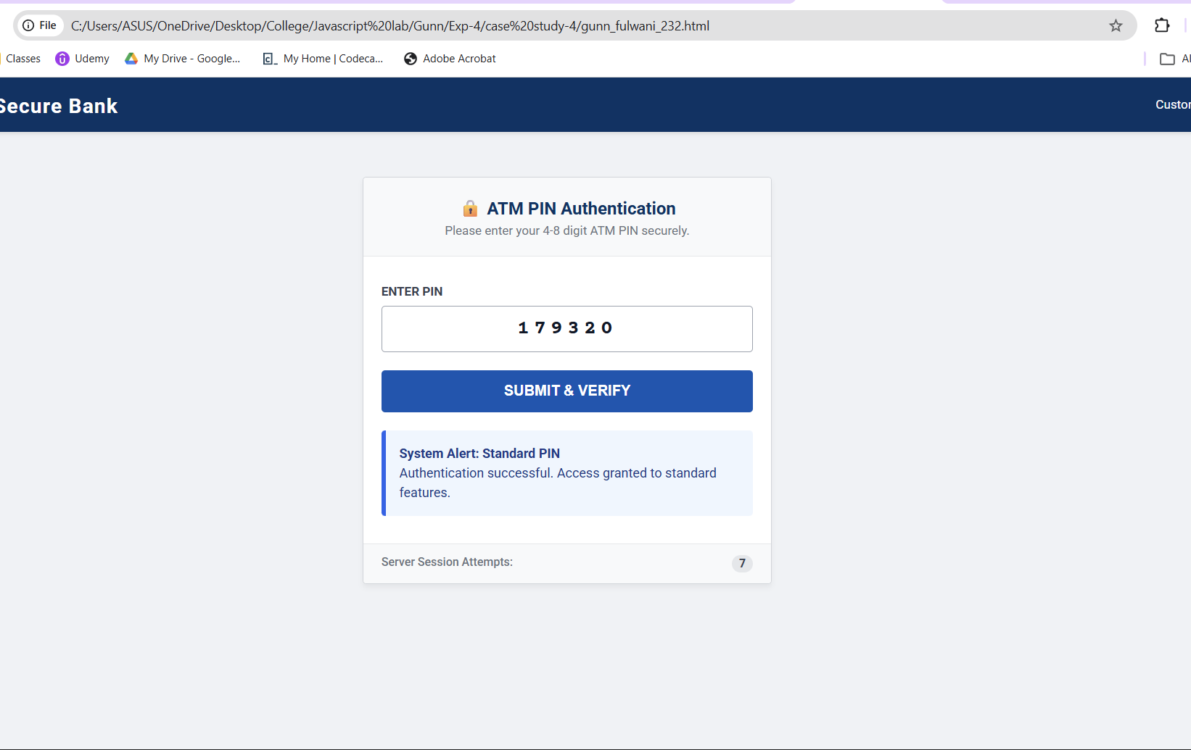

Result/Conclusion:
The case study was successfully completed. The ATM Card PIN Verification system was implemented using three distinct JavaScript function types: declarations, expressions, and arrow functions. Furthermore, a secure lexical closure was successfully integrated to track user attempts independently of the global scope. Form validation and robust error handling were achieved using a try...catch block, resulting in a secure, dynamic, and aesthetic web interface.

